Alternate Extension “Learning”
Description:
- The feature Alternate extension has been around for a long time.
  - many users don’t take the time to configure it given that it is buried in the CPCA and SA. This feature addresses this issue.
    - Unity will keep track of how many times a subscriber logs in to their mailbox from an unrecognized number by keeping track of the number or Calling Party ID (CPID) from which they are calling from.
Notes:
If it is frequent enough, Unity will prompt the subscriber and ask if they would like to add the number as an alternate extension so that Unity automatically recognizes them in the future, where by they will automatically be logged in or asked for there password if configured.
Benefits of the feature:
Allows subscribers who do not use or have access to the Cisco Personal Communications Assistant, to add alternate extensions via the Telephone User Interface (TUI). Saves subscribers time in the future since they will not have to enter their mailbox number to login to their mailbox when calling from a secondary line on their desk phone, or other numbers such as their mobile device or home phone number.
How the feature is enabled and used:
- The feature is enabled by default and can be disabled in the Subscribers Class of Service.
- In the SA, select COS → Profile, see "Subscribers can add, modify and delete their own alternate extensions".

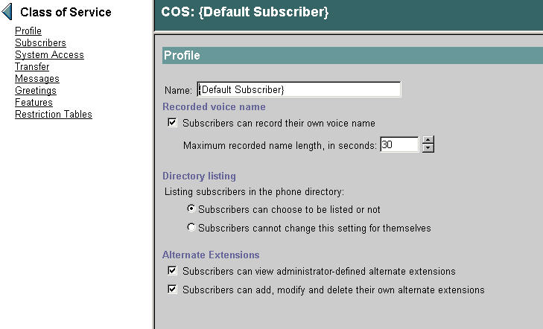
Expected/notable behaviors:
After a subscriber logs in from an unrecognized number for x number of times in the previous n number of days (x and n are configurable), Unity will prompt the subscriber and ask if they would like to add the number as an alternate extension.
Troubleshooting:
Observe the expected behavior stated above. To further troubleshoot you can start by collect ting the following AvSaDbConn( all) traces.
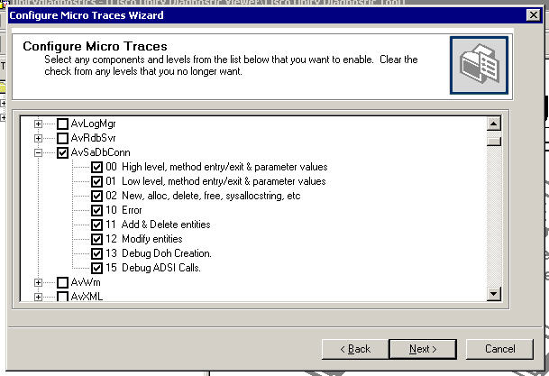

Appendix:
When enabled, the Unity system will prompt users to configure their alternate extension when they access their mailbox from an unrecognized number multiple times.
Once a subscriber has added an alternate extension via the TUI or CPCA, the subscriber can remove the number as an alternate extension via the TUI by accessing their setup options and choosing personal settings. The subscriber must be calling from the alternate extension or the option to remove the number will not be offered.
Note that subscribers must be calling from the alternate number in order to have the option to remove the number. They will only be offered to remove numbers for which they have added. A subscriber will not be offered to remove an alternate number which was assigned to the subscriber in the SA by an administrator.
Administrators can configure how many times a user must call from a given number over a given amount of time before the system prompts the subscriber with the option to add the number as an alternate extension. The default is 5 times over the next 30 days and can be configured in the SA under Configuration → Settings. Look for, “Alternate Extension Setup based on CPID” on this SA web page.

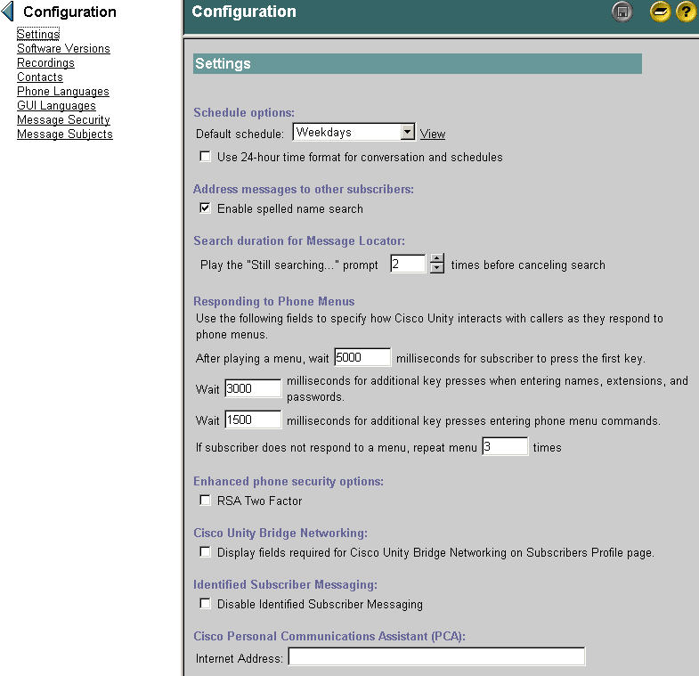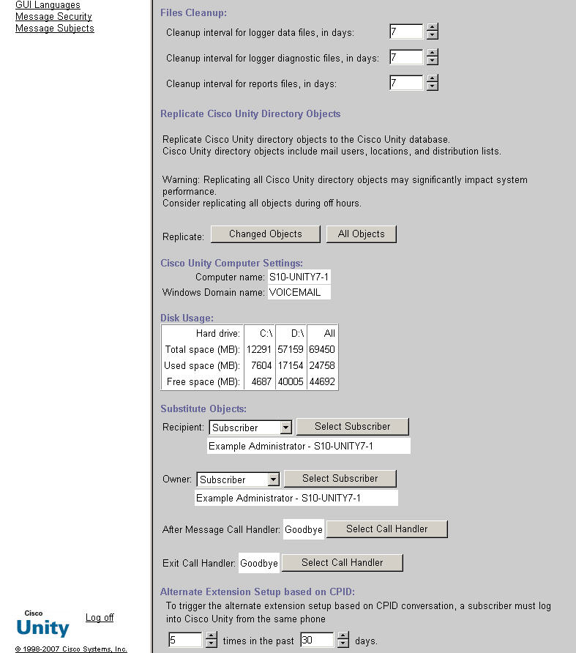
Additionally, administrators can restrict the minimum and maximum number of digits that the calling number must be before the number is considered for this feature to apply. For example, and administrator may wish that the calling number must be at least 10 digits long in order to be considered. This prevents for example Unity from evaluating 4 digit extension numbers within the organization such as lobby, conference room, labs, and break room extension numbers from being evaluated. Further more an administrator can restrict specific numbers or number patterns. By default a number must be at least 10 digits long to be considered. To change the defaults in the SA, go to Restriction Tables and search for the “[Default Alt Ext] restriction table.
Reference

Cisco Unity 7.0 Release notes:

http://wwwin-eng.cisco.com/Eng/ECSBU/Unity4x_Product_Team/EFT_Docs/Unity_7.0/CiscoUnity7.0.1EFT1_ReleaseNotes.doc
FFS:
http://wwwin-eng.cisco.com/cgi-bin/edcs/edcs_info?EDCS-629390

