Configurable voice mail subjects

Description:
- The administrator can configure the format of voicemail subjects for 4 types of messages Via the Unity SA:
  - outside caller message,
  - subscriber messages,
  - interview handler messages,
  - live record messages.

- The voicemail subjects can be localized to the default TUI language for the Unity system, that can include:
  - Caller ID and Name
  - Called ID and Name
  - Sender ID and Name
  - and the message flags for urgent, private, and secure.
Note:
Voicemail subjects will not be announced when a subscriber listens to a message over the TUI, but they will be seen when the subscriber accesses their messages via a GUI client such as VMO or Unity Inbox.
How to use:

- Open the Unity SA, and go to the page System \ Configuration \ Message Subjects.
- On that page, you'll see the default message subjects and replaceable parameters.
- These can be customized as you desire, and localized if your system's default TUI language is not US English.
  - When subscribers access their voicemail messages via a GUI client such as VMO or Unity Inbox, they'll see the message subject.

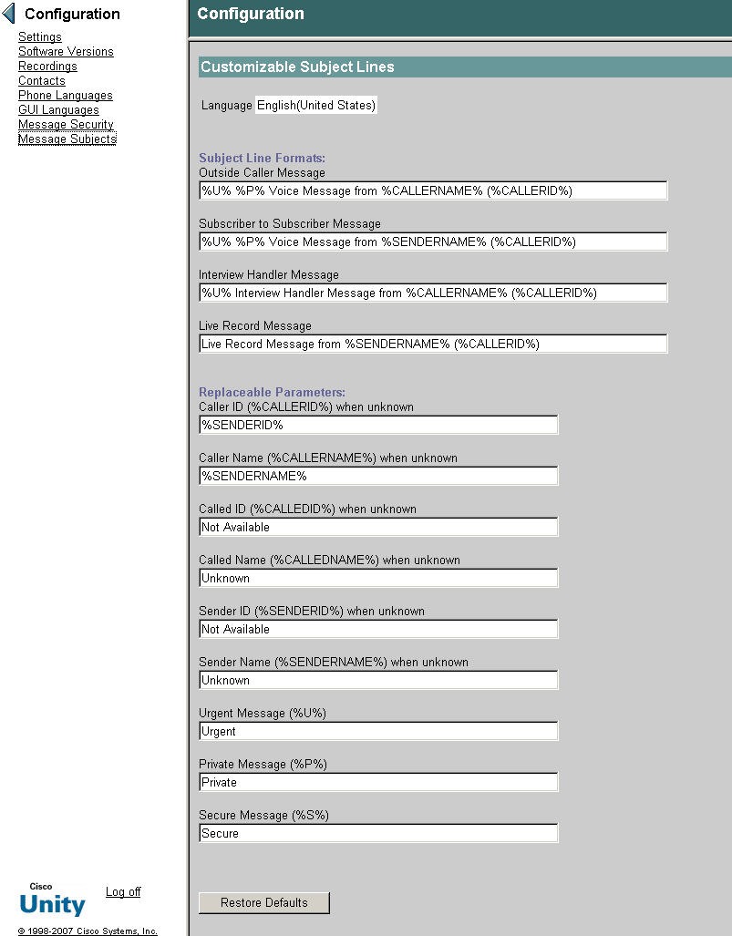

Note: this only affects new messages that are sent after an upgrade to Unity 7.0; if you have upgraded from an earlier Unity version, messages sent at that time will not have customized subjects.

Benefits:

Voicemail subjects can be localized and customized, and can include phone numbers and names of the sender/caller, plus indication of message urgency, privacy, and security.

Notable Behavior:

A subscriber will NOT hear a voice mail subject when they listen to their messages over the phone. Also, note that this only affects new messages that are sent after an upgrade to Unity 7.0; if you have upgraded from an earlier Unity version, messages sent at that time will not have customized subjects. Finally, the values for Caller ID, Caller Name, Called ID, and Called Name come from the phone system, so they will only be available if the phone system is configured to present that information to Unity; this is particularly notable for messages from outside callers, since often a phone system will not be configured to provide external caller names.

Troubleshooting:
MACRO TRACES:
1) Call Flow Diagnostics
2) Conversation State Traces
3) Call Control (Miu) Traces

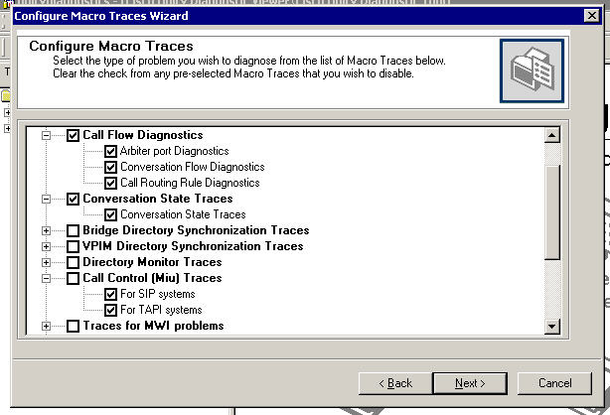

MICRO TRACES:
1) Conversation Traces( ALL)

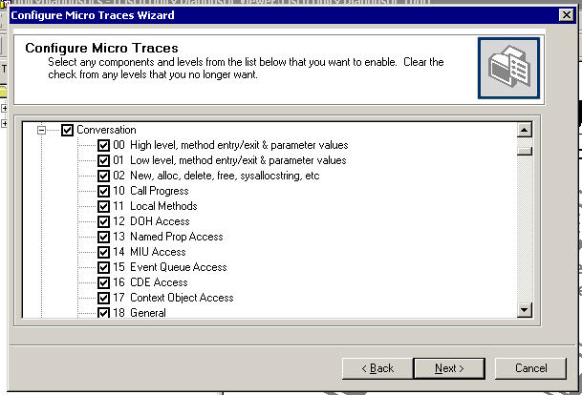

2) Conversation Utilities ( ALL)

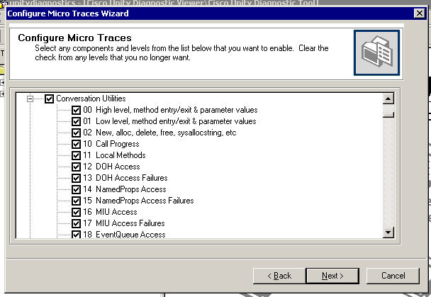
Reference

Cisco Unity 7.0 Release notes
http://wwwin-eng.cisco.com/Eng/ECSBU/Unity4x_Product_Team/EFT_Docs/Unity_7.0/CiscoUnity7.0.1EFT1_ReleaseNotes.doc

FFS:

http://wwwin-eng.cisco.com/cgi-bin/edcs/edcs_info?EDCS-629710

