Description

Enhanced TUI Addressing

Description:

- Enhanced TUI Addressing is a new feature that is designed to improve addressing when using DTMF input and decrease the number of DTMF necessary to get to a particular address;

          - Applies to Address by Name only, not to Address by Extension or VUI Address Searcher.
          - It is composed of two parts: Most Recent Used (MRU) List and Constant Lookup.
            - The MRU List works by taking all the matches to the entered criteria, then sorting the ones that the user has most recently used to the top of the list. Every time a user confirms selection of a name, that name is added to the MRU list.
            - Constant Lookup works be performing a lookup after every entered digit (need at least 2) and sounding a prompt (not a menu).

- It will trigger in any of the following conditions:
a) There is a single exact match found in which case the name is
announced (aka Name Suggest)
b) There are between 2 and 6 matches found, in which case Unity says "X matches found"

Note: The prompt is NOT a menu, the user can continue to enter additional input if they want.

Benefits:

Whenever a user addresses to a name, that name will be added to the MRU List, which results in the name being presented higher in the match list. After the MRU list has been populated, the user might only need to dial 2 or 3 digits to get the name they want - or at least within a couple matches of it. Constant Lookup is sort of any "audible crutch" of the currently entered search criteria to allow non-power-users to determine if they've entered enough digits.

How to Enable:

MRU List is always on and cannot be disabled. Constant Lookup is disabled by default, but can be enabled via the Subscriber's Conversation page. The features will be available any place that a subscriber (not an outside caller) can address by name.

Expected/Notable Behaviors:

Constant Lookup may introduce an additional performance hit on the system, depending on the size of the database and number of callers addressing at any given time.

Troubleshooting

Look for signs of performance hit on the system. Perfmon is good way to start monitoring processes.

Following Trace will be helpful in troubleshooting the problem

MACRO TRACES:
- Call Flow Diagnostics
- Conversation State Traces
- Call Control (Miu) Traces

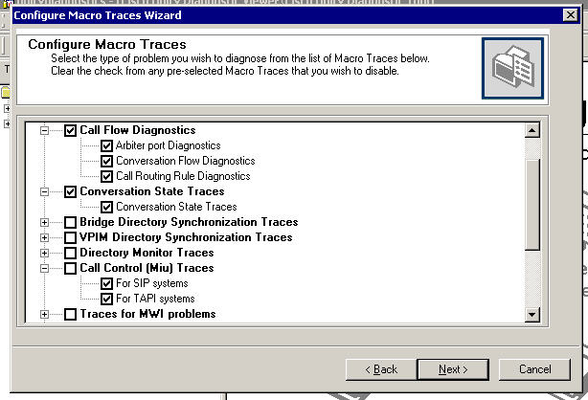

MICRO TRACES:
- Conversation Traces( ALL)

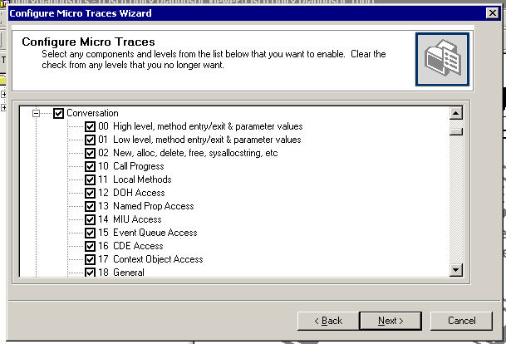

- Conversation Utilities ( ALL)

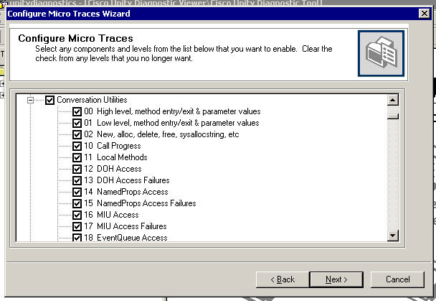

- PhraseServer 11 ( phrase ID and Wave file Info)

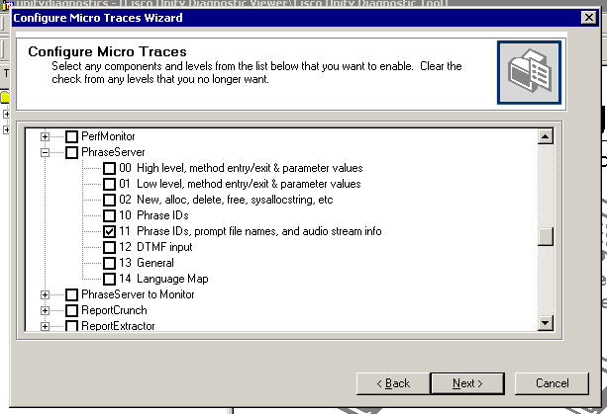
Appendix A

Updated TUI Setup Options

More conversation settings are available through TUI with Unity 7.0.
The Menu can be accessed from Subscriber menu “Press 4”

- Sticky message speed.
Once you changed the play message speed during message retrieve, the speed setting will be saved and used next time.

- Sticky prompt speed.
Once you changed the prompt during message header, the speed setting will be saved and used next time.

- TUI set up brief/full prompts.
Use this setting to turn on the brief and full prompt.
Menu Key: 4->2->3

- TUI set up SMS notification
Use this to turn on/off SMS notification device. You can also set the phone number and review the SMS notification device settings.
Menu Key: 4->2->1->5

- Conversation send style.
Use this to turn on/off Streamlined Send style
Menu Key: 4->2->5

- TUI set up play name after sign in.
Turn this on to play your recorded name after sign in otherwise to message count directly.
Menu key: 4 -> 2 -> 7

- TUI set up play messages at sign in.
When on turn, system play new message after sign, if off you have to access your messages through the main menu.
Menu key: 4 -> 2 -> 8

- "Name Suggest" on/off
Use this to turn on name suggest feature.
Key menu: 4->2->6

Diagnostic:
Macro traces: call flow diagnostics and conversation State traces
Micro traces: phraseserver 11 (phrase ID and wave file info)

Reference

Cisco Unity 7.0 Release notes:

http://wwwin-eng.cisco.com/Eng/ECSBU/Unity4x_Product_Team/EFT_Docs/Unity_7.0/CiscoUnity7.0.1EFT1_ReleaseNotes.doc

FFS:

http://wwwin-eng.cisco.com/protected-cgi-bin/edcs/edcs_attr_search.pl?doc_num=EDCS-635703

