Outside Caller May Mark Message As Private

Description

- A caller unknown to Unity, herein referred to as an “Unknown Caller”, which leaves a message for a subscriber or a call handler may now mark that message as “private.”
- The end recipient of a “private” message will be unable to forward that message to another recipient through the Telephone User Interface.

- This feature also applies to subscribers leaving a message for another subscriber, a call handler, or an interview handler through Identified Subscriber Messaging (ISM).
- ISM in this case is where Subscriber A calls Subscriber B’s telephone and forwards to Subscriber B’s voicemail greeting and leaves a message.

Benefits of the feature

- This feature will now allow callers to mark a message as private preventing the recipient of the message from forwarding the message to another subscriber or external address.
- The message recipient will be unable to forward the voice message to another person via the telephone user interface (TUI), the Cisco Personal Communications Assistants Cisco Unity Inbox or from Microsoft Outlook when View Mail for Outlook is installed.

Note: Previously, only a known subscriber sending a message from within their own mailbox (i.e. after a successful log-in) could mark and send a message as private.

How the feature is enabled and used

- This feature is controlled on a per-subscriber and call handler basis.
- Enabling and disabling the feature varies depending on whether the message is being taken by a subscriber or a call handler.
- The table below indicates the two primary avenues for controlling this feature.

Table 1: Where to enable and disable the feature in the SA and PCA
Entity Taking Message | SA | PCA
Subscriber | Subscribers → Messages | Preferences → Transfer & Screening Options
Call Handler | Call Handlers → Messages | Not Applicable

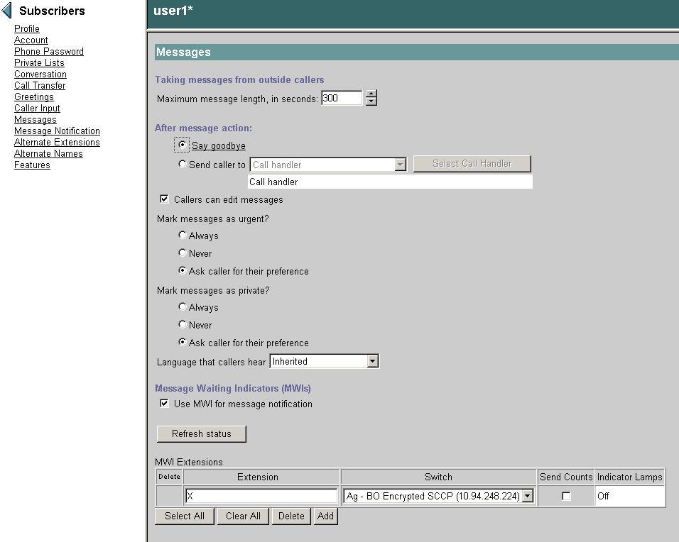

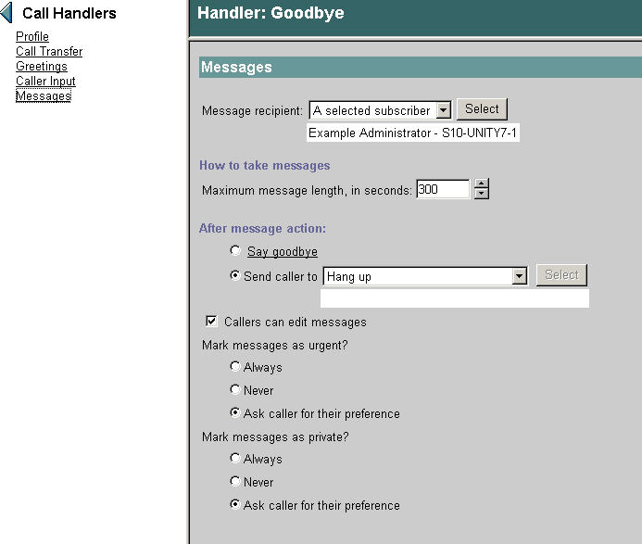

The Bulk Edit utility may also be used to set the status of this feature for multiple subscribers or call handlers at a time.

Expected/notable behaviors

- A message marked “private” is not the same as an encrypted message. A voice message may be private or encrypted or private and encrypted.
- Encryption of messages from Outside Callers is controlled through the Configuration → Message Security page in the SA.

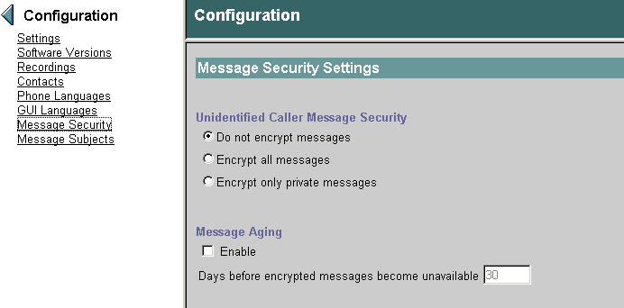

Troubleshooting:

Macro Trace:

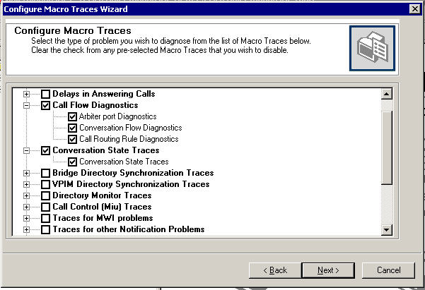

Micro Traces:

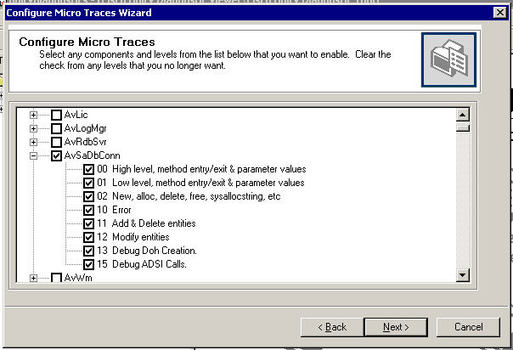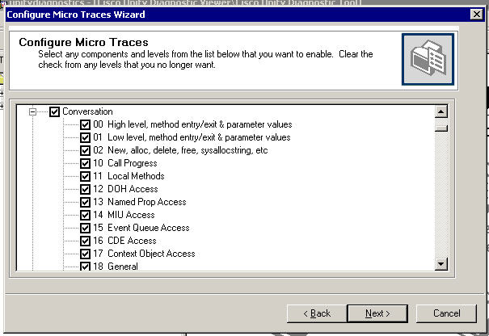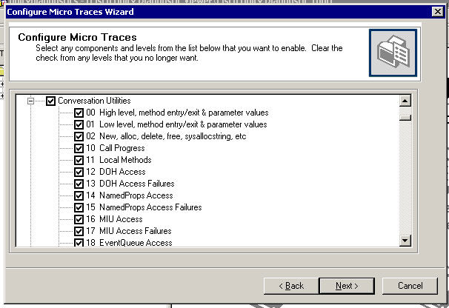

APPENDIX:

In the relevant SA page there are actually three settings for this feature. A subscriber or call handler can specify whether messages left by callers should never be marked private (feature is disabled) or always marked private (feature enabled). In both cases the person leaving the message will not hear any prompt related to marking a message as private. Unity will simply take the appropriate action depending on the setting. A third option is to ask the caller their preference. In this case the caller will hear a menu option for marking the message as private after recording the message.

For individual subscribers, the PCA Transfer & Screening Options page contains a single check-box labeled “Mark the message as private.” If checked, callers will be given an option to mark the message as private. Likewise, if the box is left un-checked, callers leaving a message will not be given the option to mark the message as private. Note, there is one caveat in that if the Administrator configures a subscribers mailbox in the SA to “always” mark messages private, the check box “Mark the message as private” in CPCA will be enabled yet callers will not be asked and all messages will be marked as private. A subscriber can work around this by unchecking the “Mark the message as private” box in CPCA, saving the page, and then enabling the check box again, at which time callers will then be asked if they would like to mark the message as private.

Reference

Cisco Unity 7.0 Release notes:

http://wwwin-eng.cisco.com/Eng/ECSBU/Unity4x_Product_Team/EFT_Docs/Unity_7.0/CiscoUnity7.0.1EFT1_ReleaseNotes.doc

FFS :

http://wwwin-eng.cisco.com/Eng/ECSBU/Eastwood/SW_Specs/FFS_PrivateMessageEnhancements.doc

