“Sticky” message and prompt speed settings

Description:

- In Unity 7.0, subscribers can use key presses to speed up or slow down both message and prompt playback.
- In addition, once they use these key presses, the speed setting they have last used is saved, so that when call in over the phone next the same speed settings will be used.

Benefits of feature:
- Easier to change prompt speed and message playback speed.

How the feature is enabled:
- Global key commands for increasing and decreasing prompt playback speed can be assigned within the “Custom Key Mapping” tool.
- This will allow users to increase/decrease prompt playback speed from within conversation anywhere a prompt is heard.

- Users must be set to a CKM conversation style within System Administrator in order to utilize this feature:

  - From the SA → Subscribers →Conversation page for a subscriber, set their conversation style to "Custom Key Mapping".
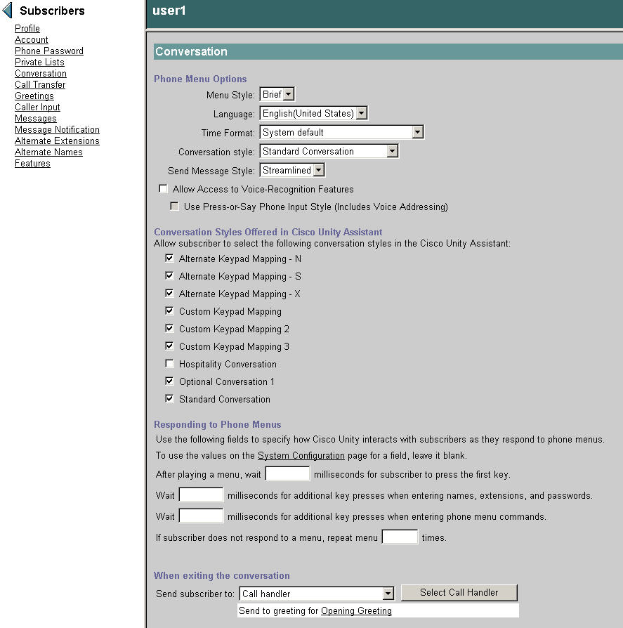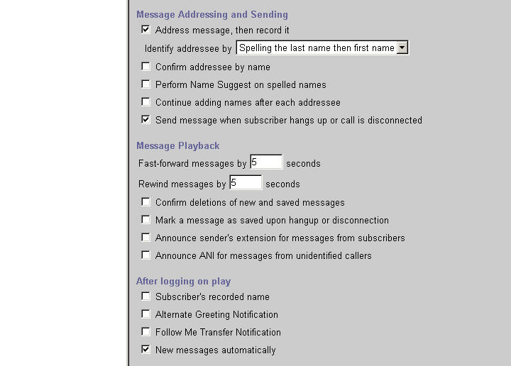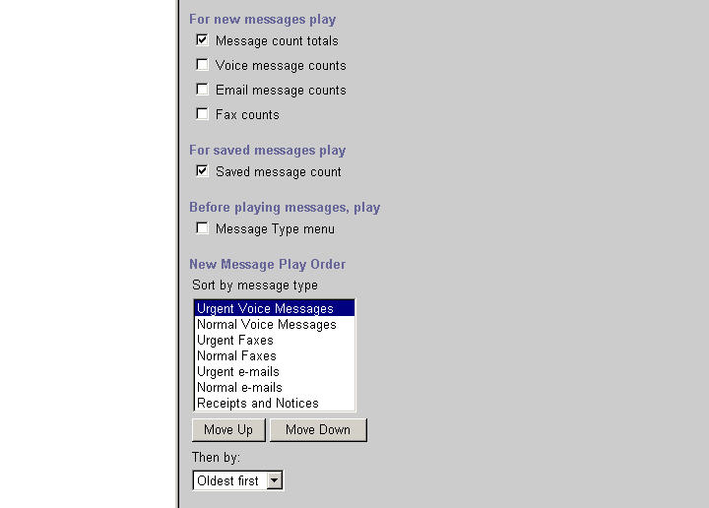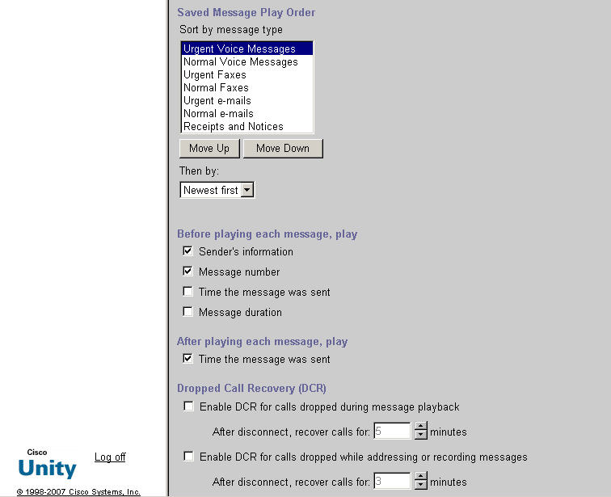

- Launch "CustomKeyMap.exe" under <drive>:\Commserver\Utilities\CustomKeyMap
- From Custom Key Mapping, navigate to the "Globals" tab and map the following keys:

  - Example keys:
[99] --> Increase Speed and Save
[98] --> Decrease Speed and Save

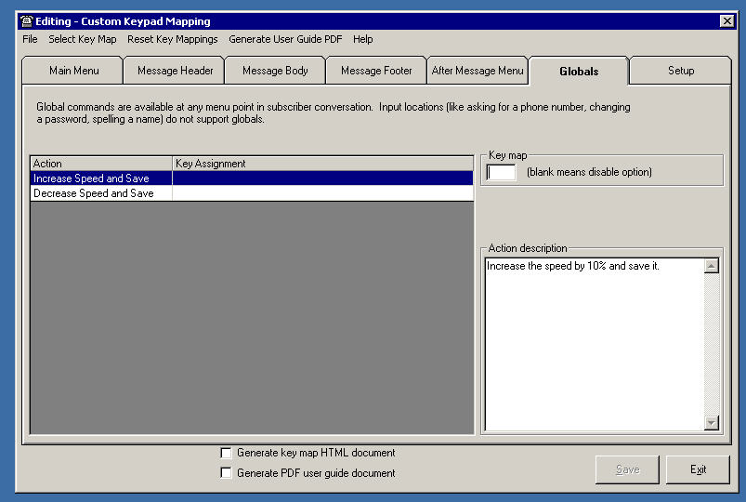

How the feature is used:
- The TUI message playback speed key sequence can be used for adjusting prompt and message playback speed when used during playback of either the <Message Header>, <Message Body> or <Message Footer>.

  - Example (Standard Conversation Style):
[4] → Decreases prompt or message playback speed when used during the message header, message body or message footer.

  - [6] → Increases prompt or message playback speed when used during the message header, message body or message footer.

Notable behaviors
TUI prompt and message playback speed settings can be altered and saved utilizing the message playback key sequence.

TUI prompt playback speed settings can be altered and saved utilizing the global CKM command key sequence.
Troubleshooting:
Macro Traces:
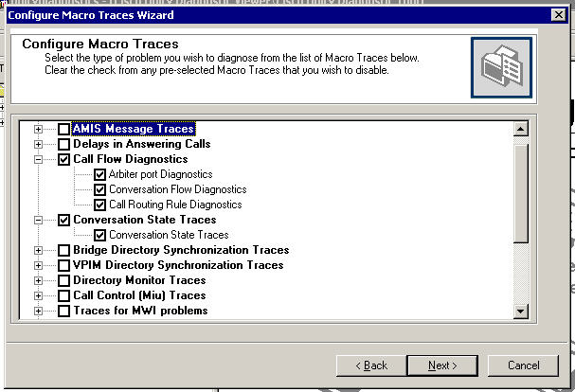

Micro Traces:
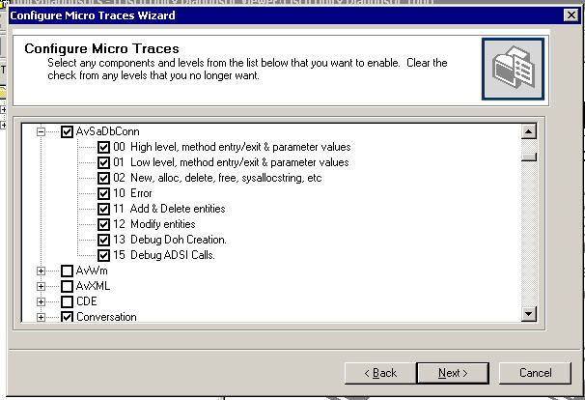
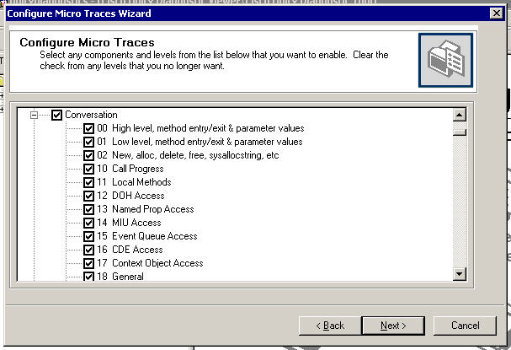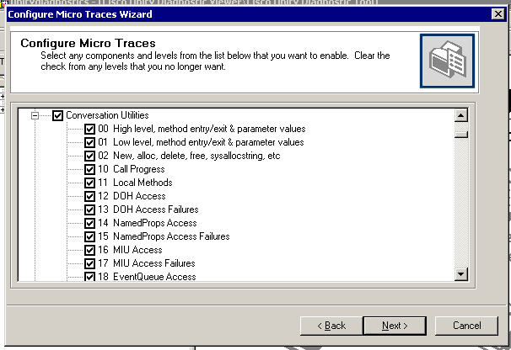

Reference

Cisco Unity 7.0 Release notes:
http://wwwin-eng.cisco.com/Eng/ECSBU/Unity4x_Product_Team/EFT_Docs/Unity_7.0/CiscoUnity7.0.1EFT1_ReleaseNotes.doc

FFS:

http://wwwin-eng.cisco.com/protected-cgi-bin/edcs/edcs_attr_search.pl?doc_num=EDCS-635703

